19. Develop a system using UML for Home Services System. HACS is a system controlled by a remote system such as a mobile phone and coordinates home appliances. The document furnishes the detailed design with all the UML diagrams. It encompasses CRC cards, Use Case Diagrams, Sequence Diagrams, and Class Diagrams for home appliance control systems (HACS).

USECASE DIAGRAM:

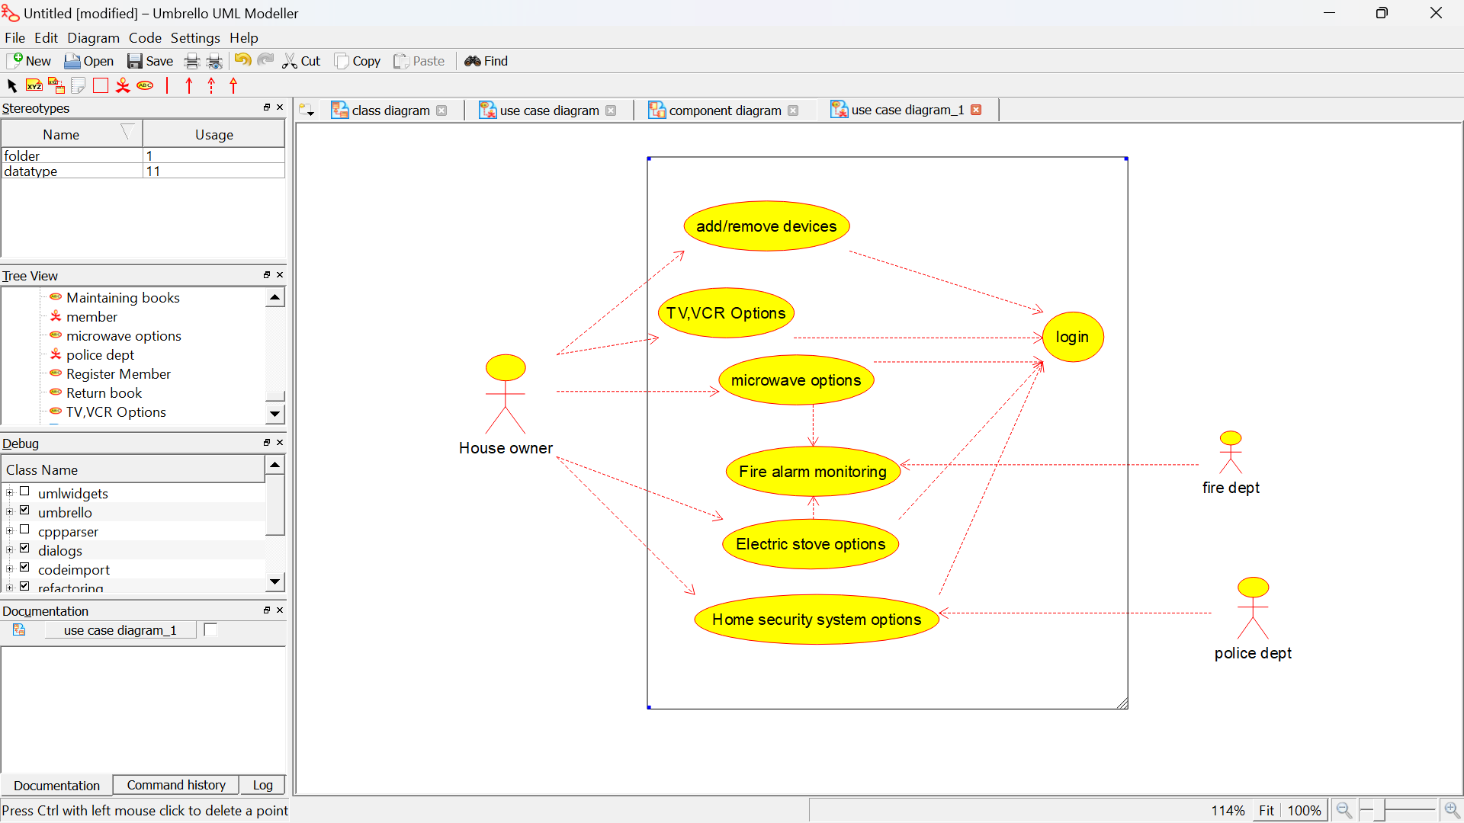

SEQUENCE DIAGRAM:

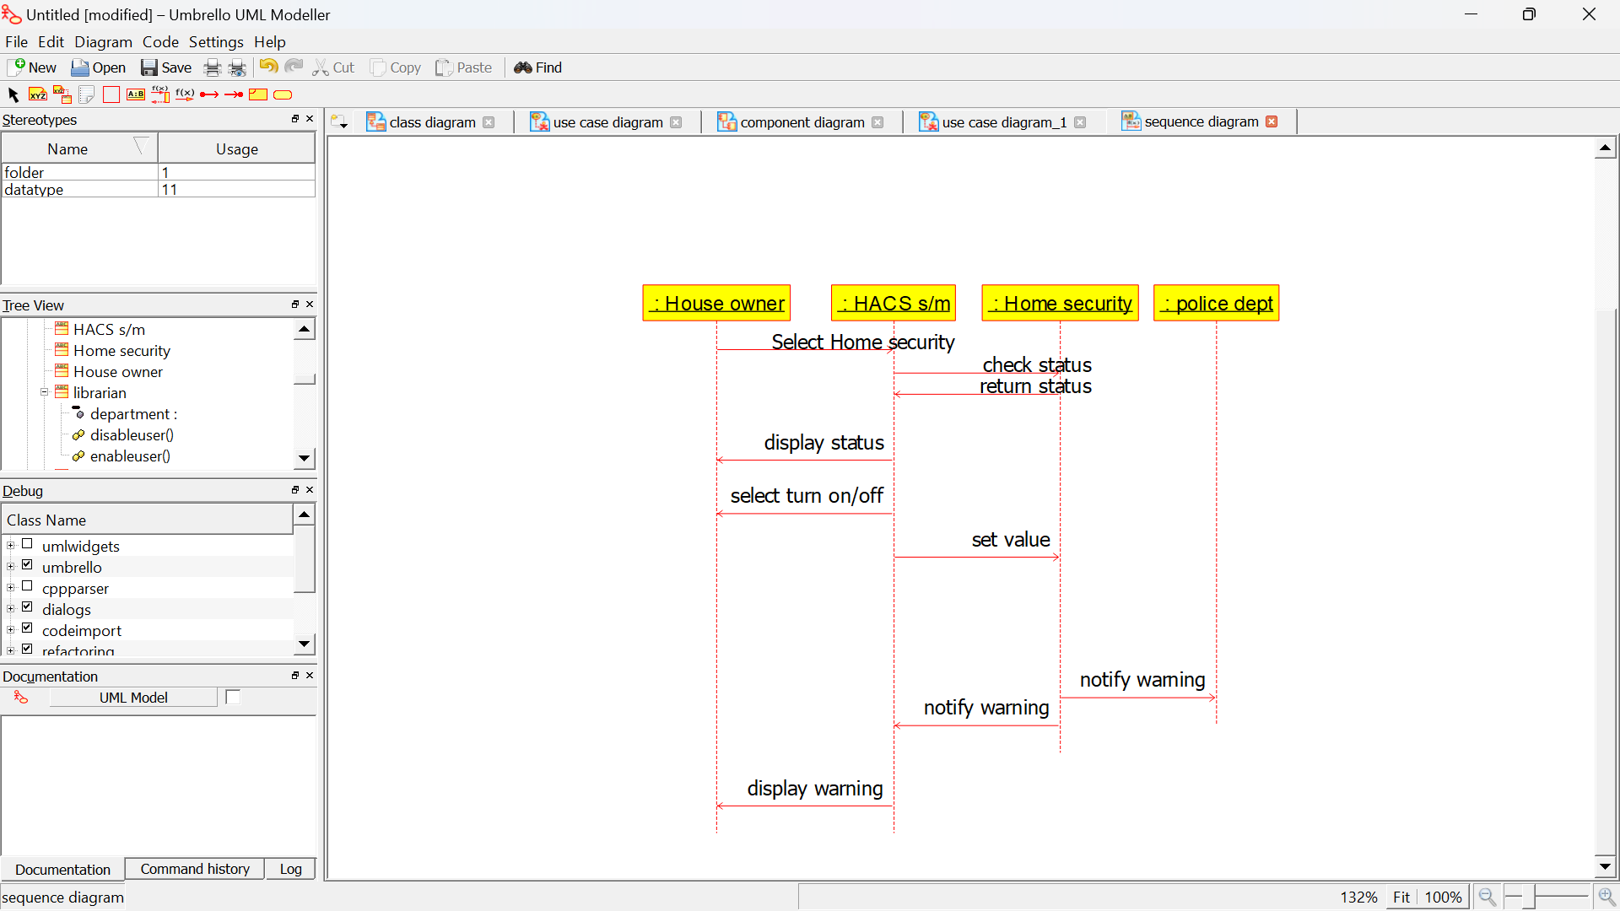

CLASS DIAGRAM:

